-------------------------------------------------

**MAVEN……NOTES……….**

**-------------------------------------------------**

**MAVEN LIFECYCLE:**

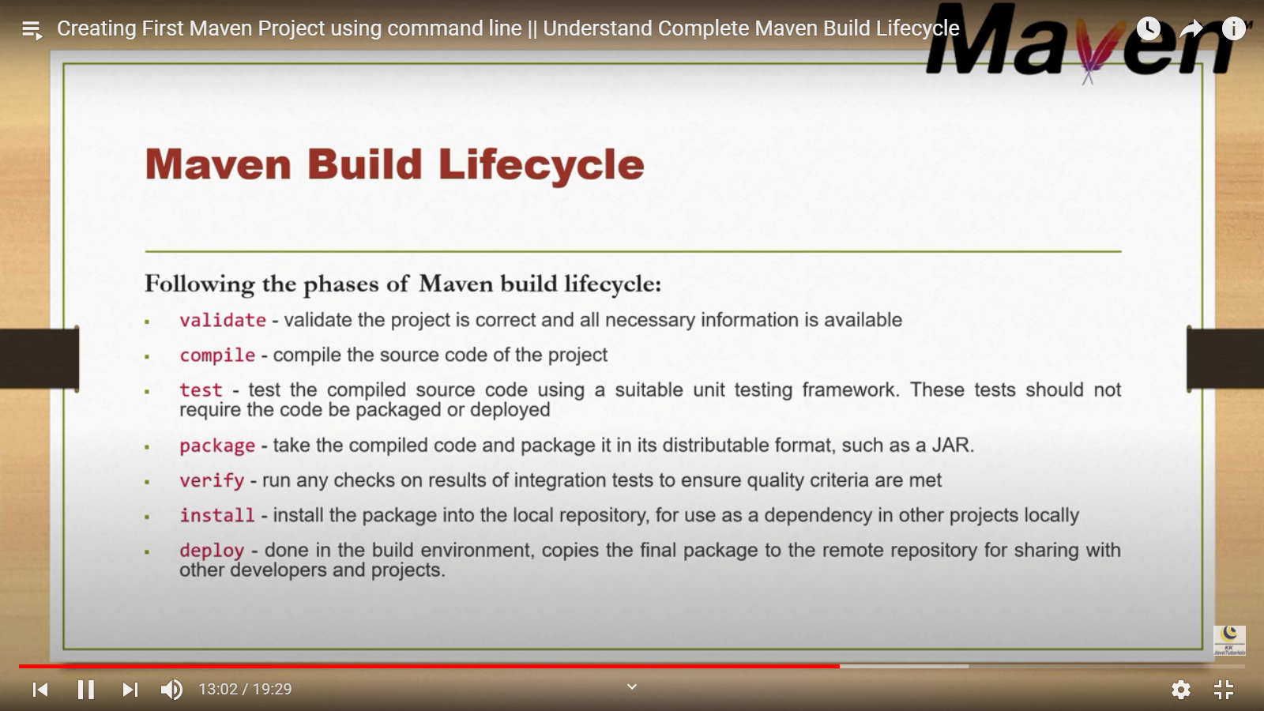

**APACHE TOMCAT**:

* Tomcat is a web server (can handle HTTP requests/responses) and web container (implements Java Servlet API, also called servletcontainer) in one.
* Some may call it an application server, but it is definitely not an fullfledged Java EE application server (it does not implement the whole Java EE API).

**JAR FILE AND WAR FILE:**

* A .war file is a Web Application Archive which runs inside an application server while a .jar is Java Application Archive that runs a desktop application on a user's machine.
* A war file is a special jar file that is used to package a web application to make it easy to deploy it on an application server

**JETTY SERVER:**

* mvn jetty:run
* mvn-Djetty.port=9090 jetty:run 🡪 to change the port no …. Default if 8080

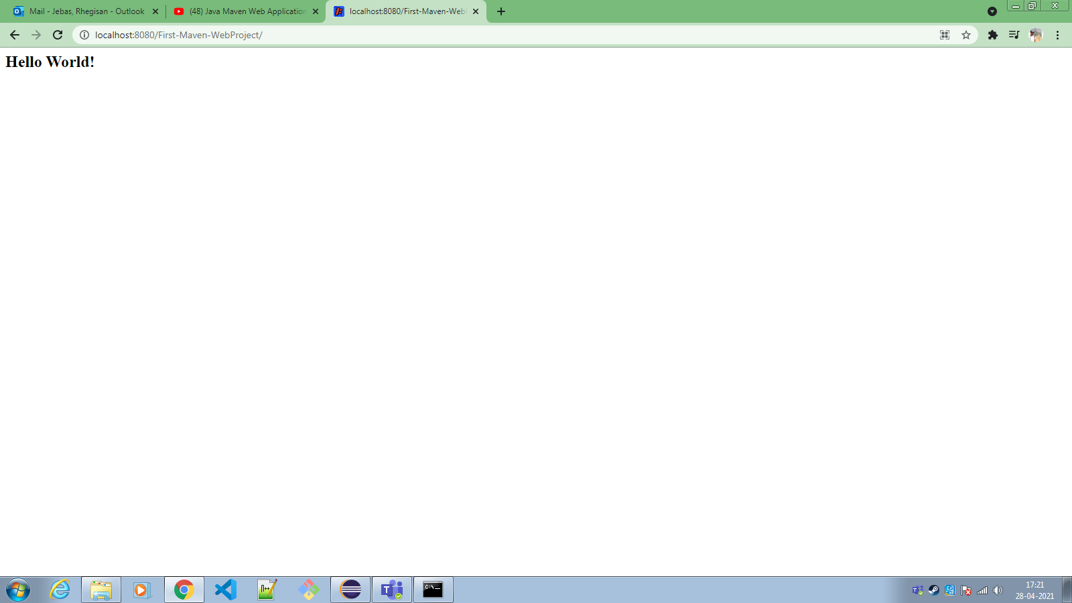

**WEBCONTAINER:**

* In Docker Container you have docker images, which has everything you need to run your application : source code, JDK,JRE, external lib..etc. Web container or Servlet Container is a type of container that only stores and communicate with your Java Servlets.

**TOMCAT PLUGIN**

* Tomcat:run

**MULTI-MODULE PROJECT:**

* Parent project packaging should be .pom

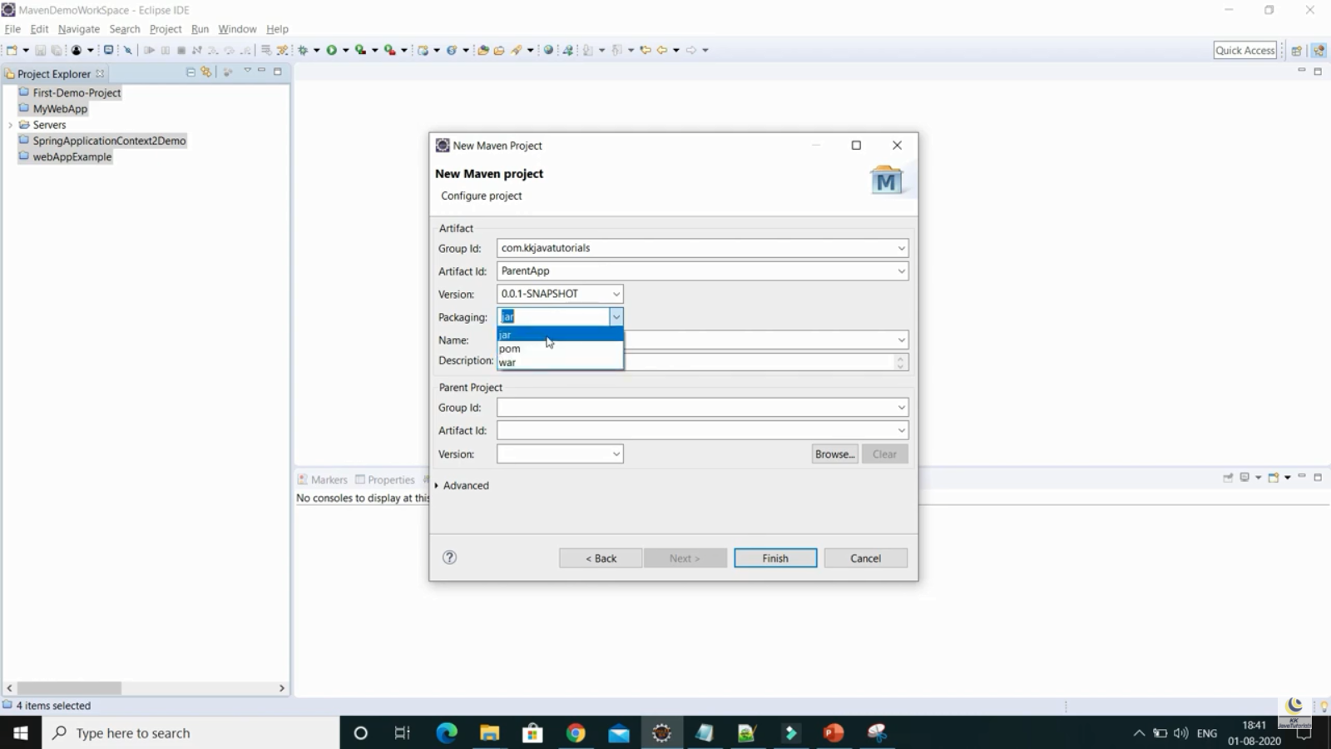­­­­­­

**DEPENDENCY SCOPES:**

* https://www.youtube.com/watch?v=rld7qShG41E&list=PLzS3AYzXBoj8E3NjjWNjrrFjyexXIyZbL&index=11

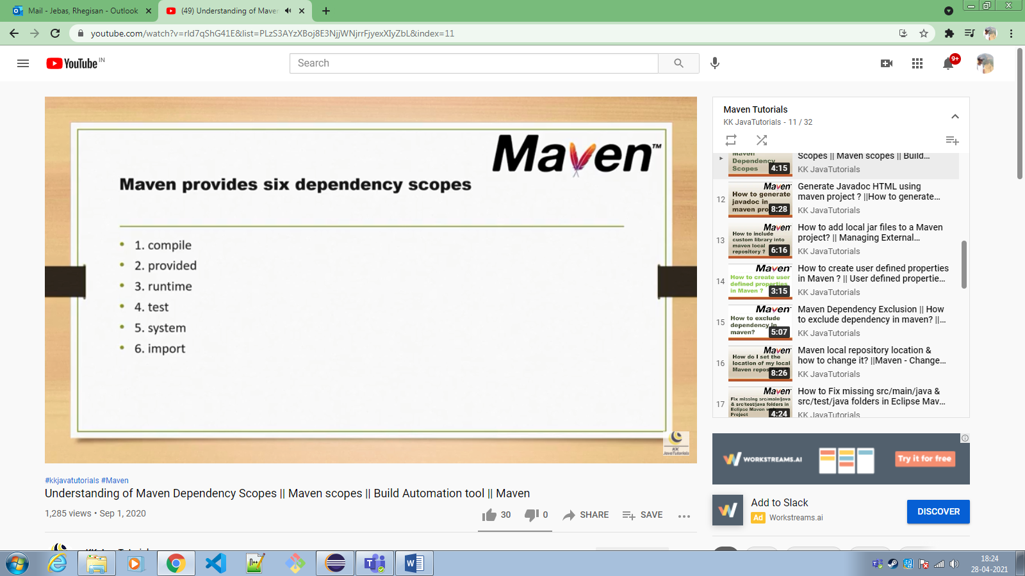

**MANAGING EXTERNAL DEPENDENCIES:**

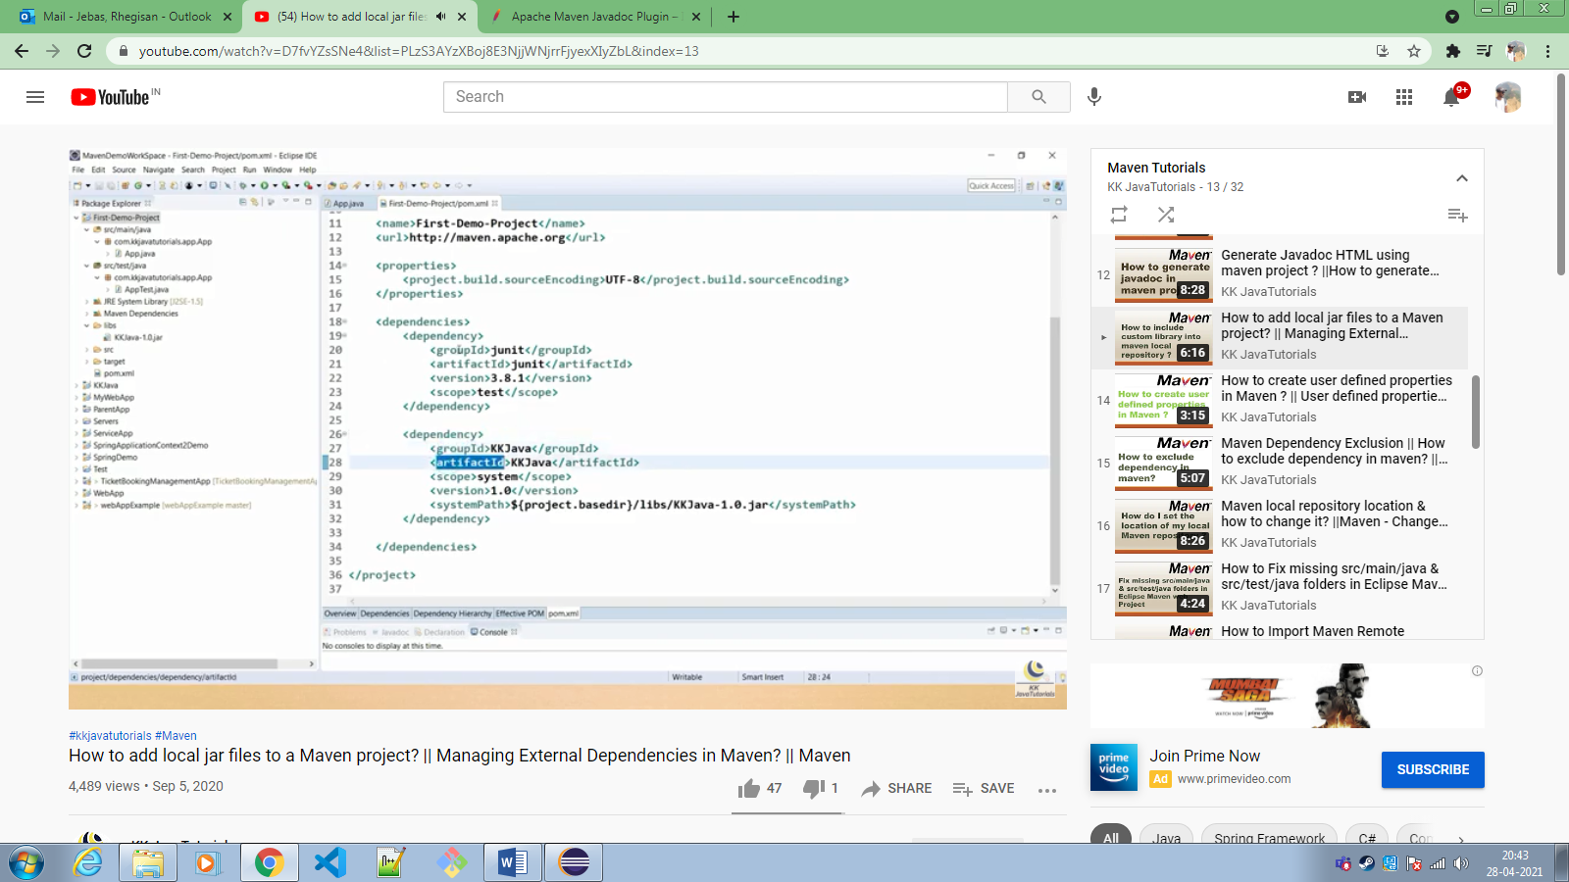

**USER-DEFINED PROPERTIES:**

* <properties>
* Saves time and effort
* Values through String interpolation “$”

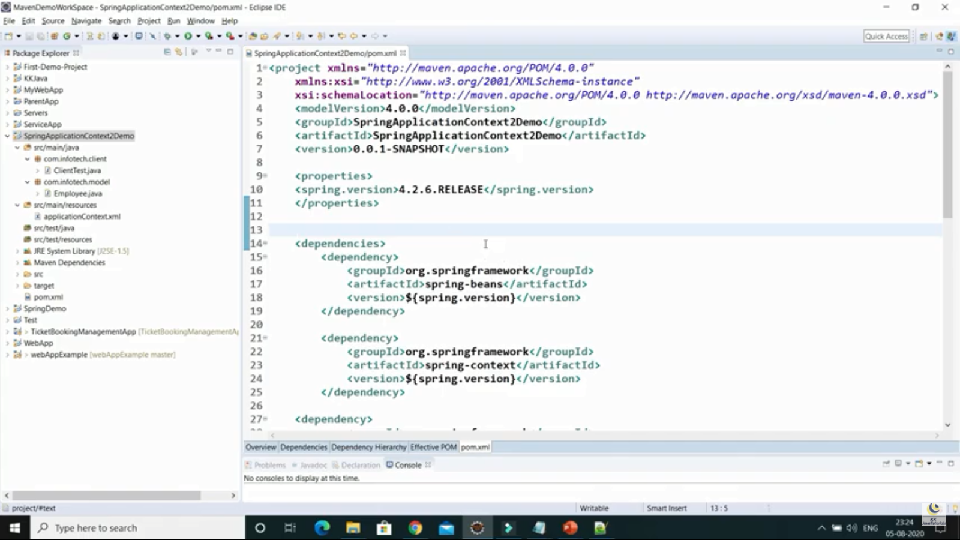

**MAVEN DEPENDENCIES EXCLUSION:**

* Excludes unwanted dependencies
* <exclusions> 🡪 <exclusion>….

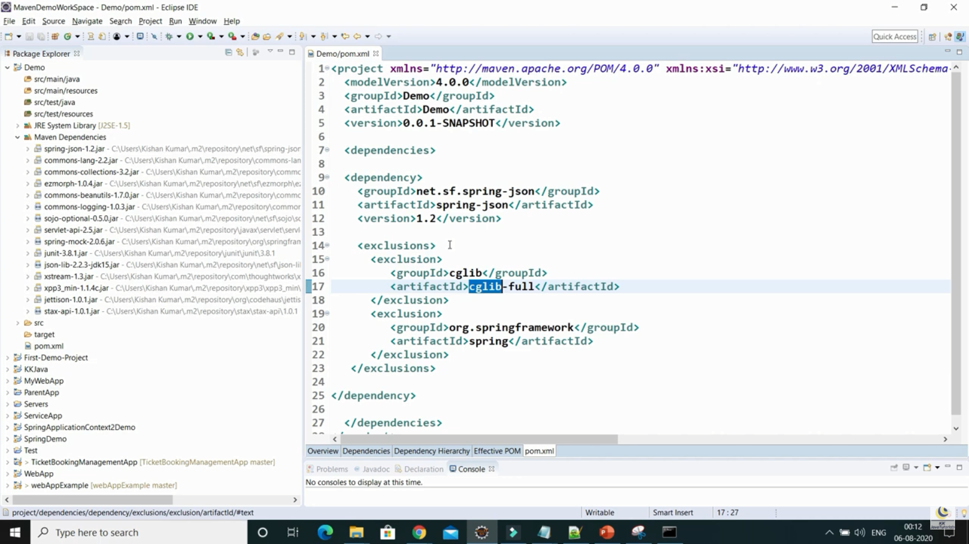

**CHANGING LOCAL REPOSITORY LOCATION:**

* Maven folder 🡪 Conf 🡪 copy settings.xml 🡪 into .m2 in User🡪 change <local repo> path 🡪 UserSettings …. update it in eclipse

**ADDING MISSING FILES:**

* Project properties 🡪 java buildpath 🡪 libraries 🡪 select default jdk 🡪 apply 🡪 update maven project

**ADDING REMOTE ARCHETYPES:**

* Windows 🡪 preference 🡪 archetypes 🡪 add remote archetypes

🡪 <https://repo1.maven.org/maven2/archetype-catalog.xml>

**PROJECT OBJECT MODEL (POM):**

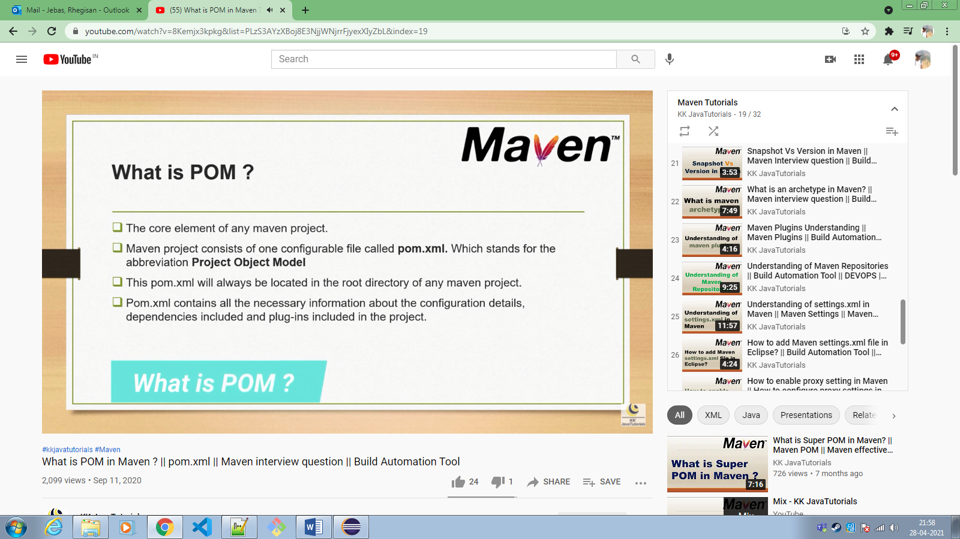

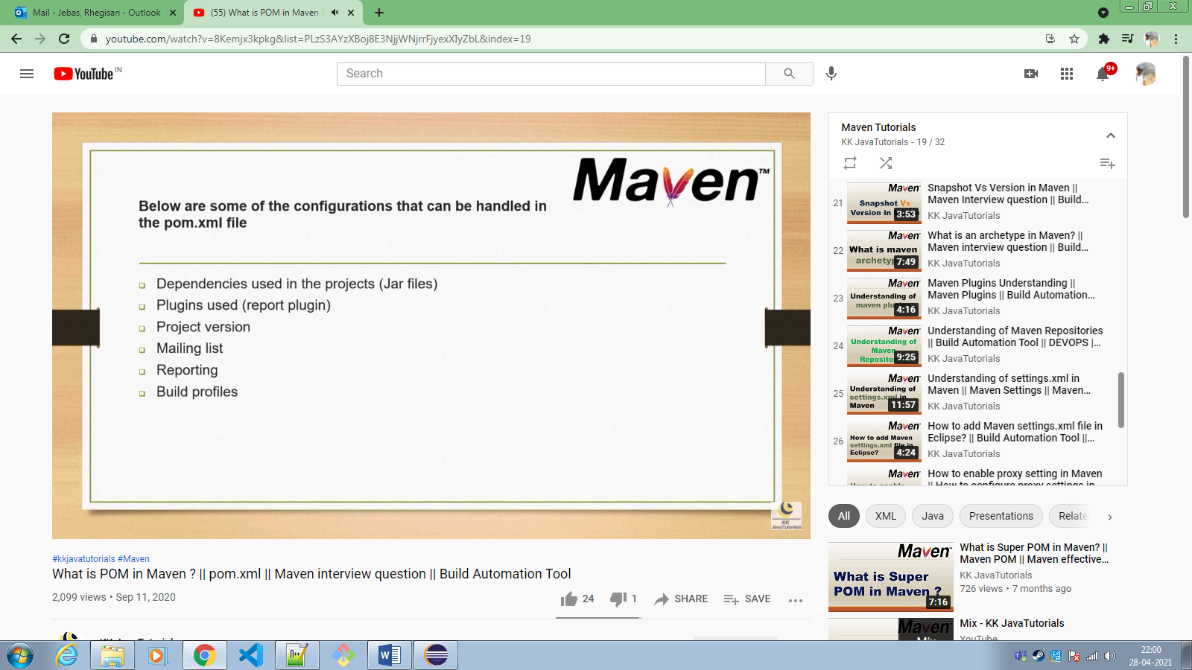

**SUPER POM FILE**:

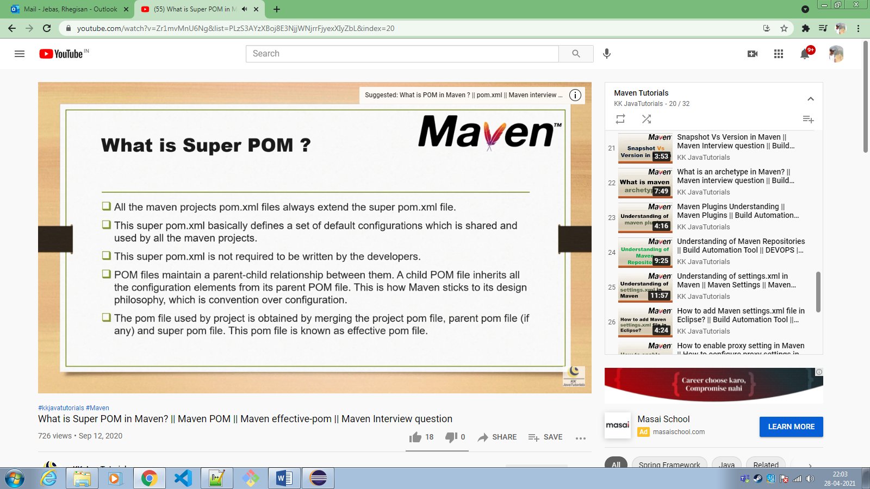

**SNAPSHOTS AND VERSIONS:**

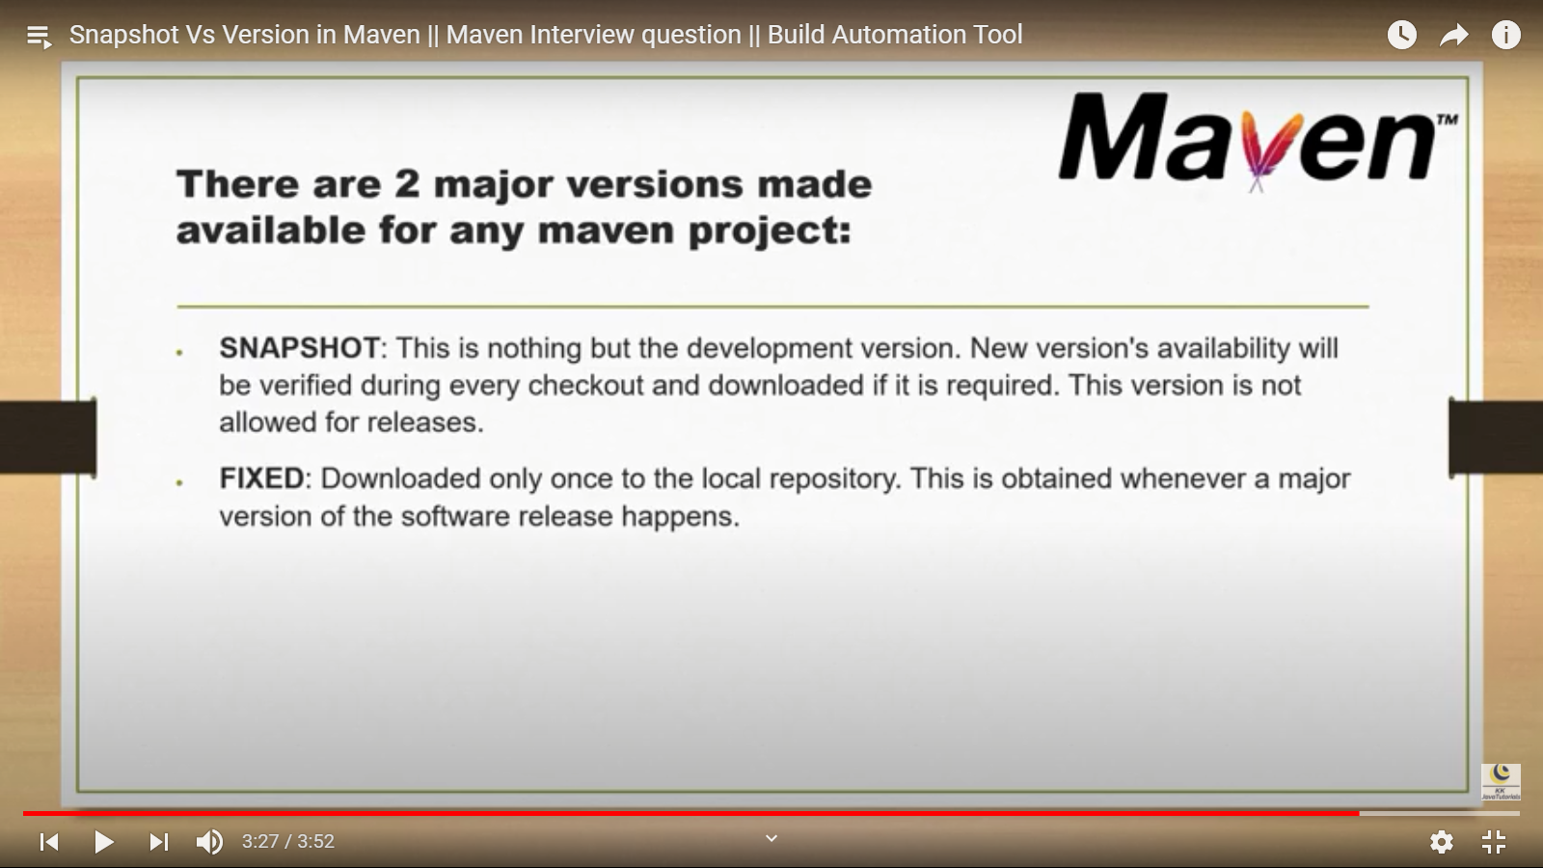

**ARCHETYPE CREATION THROUGH CLI:**

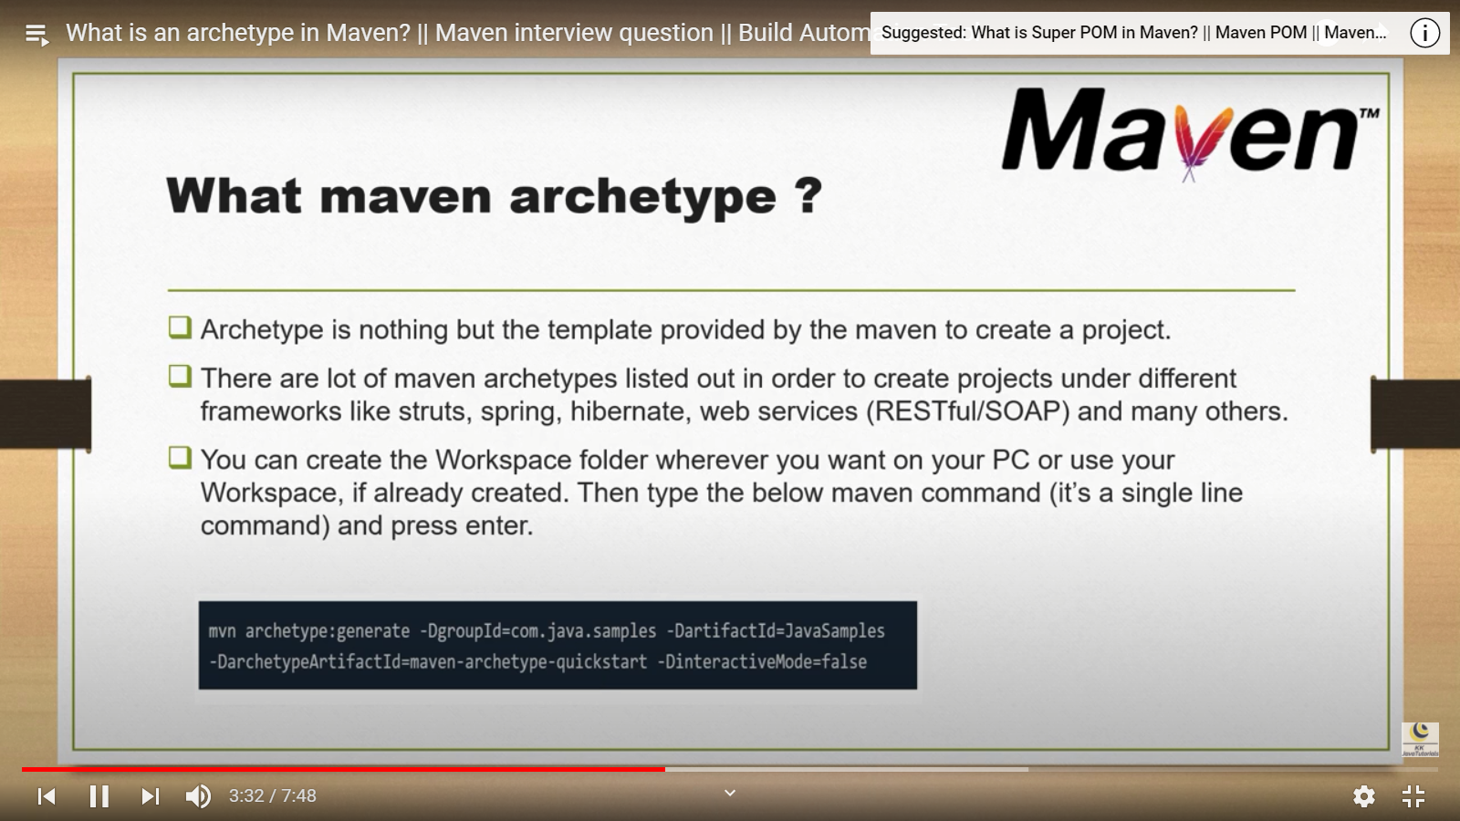

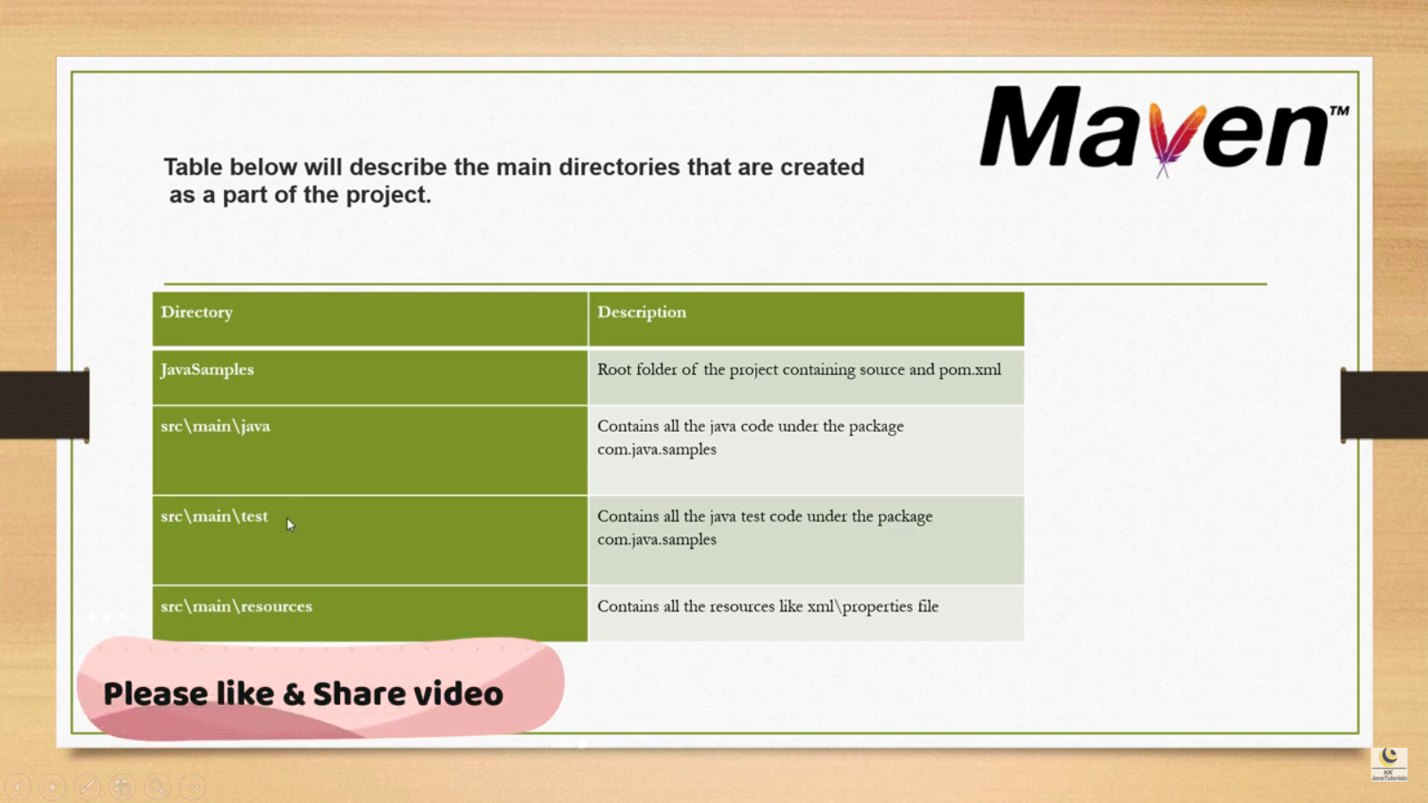

**PLUGINS:**

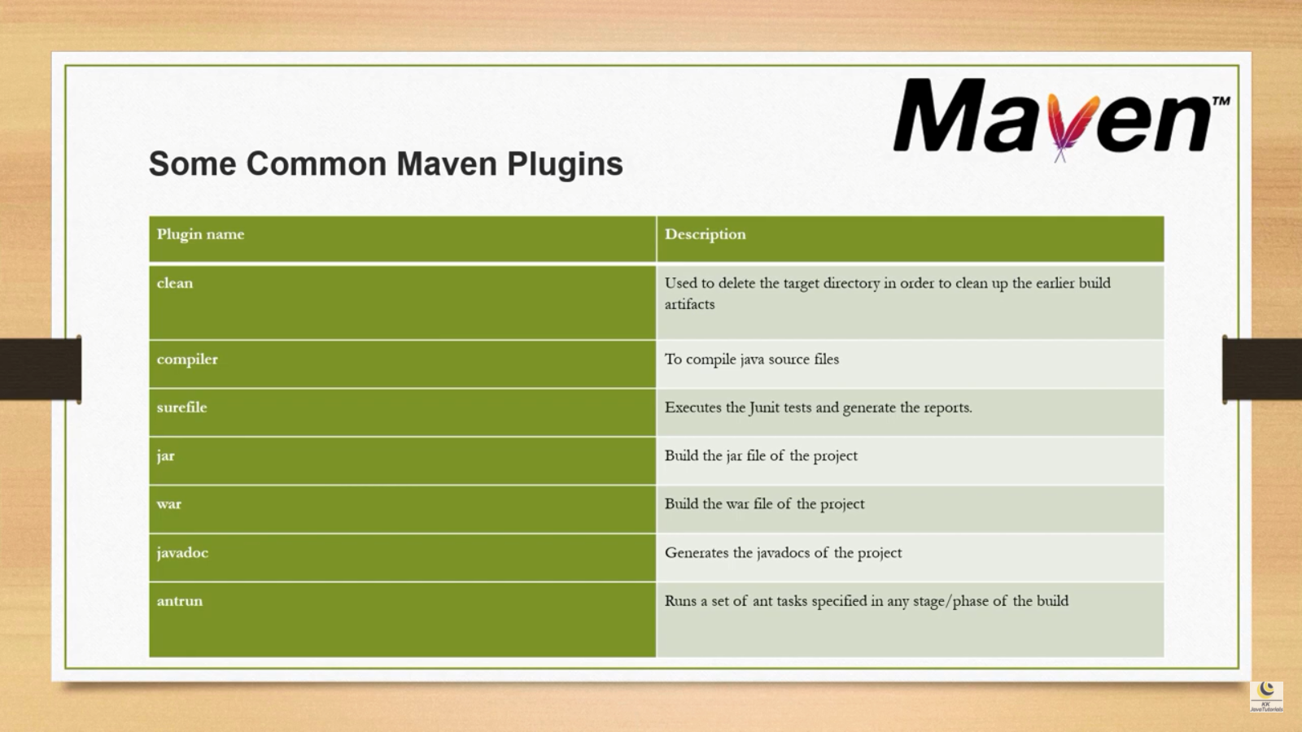

**REPOSITORY:**

* <repositories>
* Local 🡪 settings.xml
* Remote 🡪 http link
* Central 🡪 community…super pom
* BUILDING A PROJECT 🡪 local repo 🡪 central 🡪 remote

**SETTING.XML FILE:**

* https://www.youtube.com/watch?v=c6IfptPjKRM&list=PLzS3AYzXBoj8E3NjjWNjrrFjyexXIyZbL&index=25

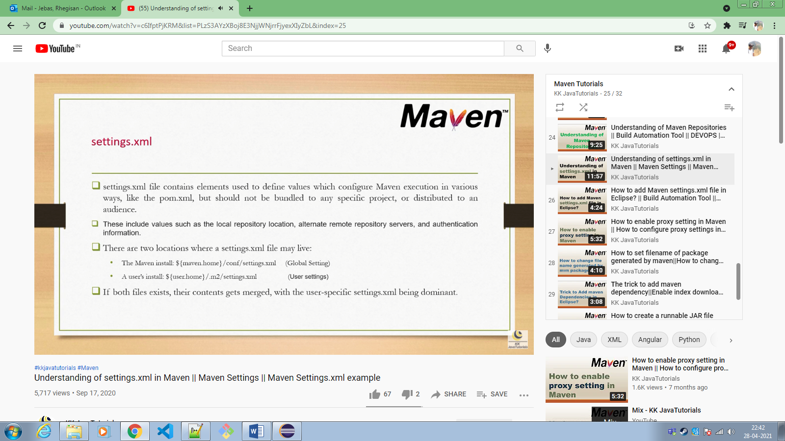

**SETTING PROXY SERVER**:

* Through settings.xml file
* Through eclipse IDE…. Windows 🡪 preferences 🡪 network

**CHANGING JAR FILE NAME:**

* <Build> 🡪 <FileName>

**EXECUTABLE JAR FILE:**

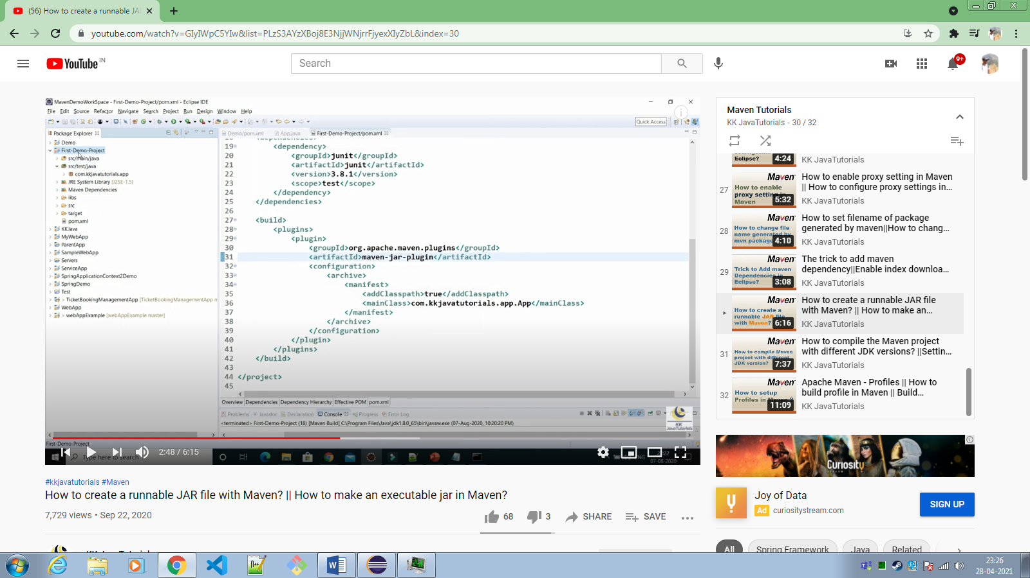

**COMPILE WITH DIFFERENT JDK VERSION:**

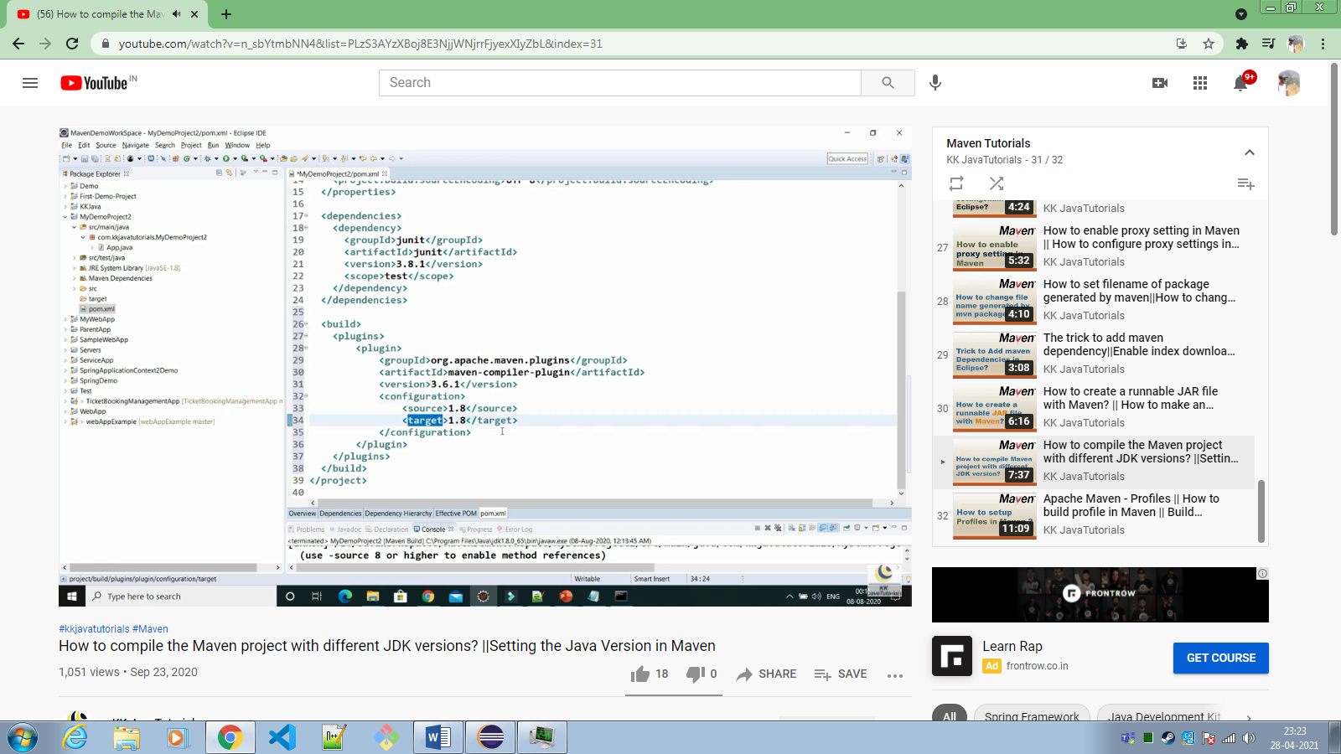

**PROFILES:**

* https://www.youtube.com/watch?v=0WacuRYhTwo&list=PLzS3AYzXBoj8E3NjjWNjrrFjyexXIyZbL&index=32

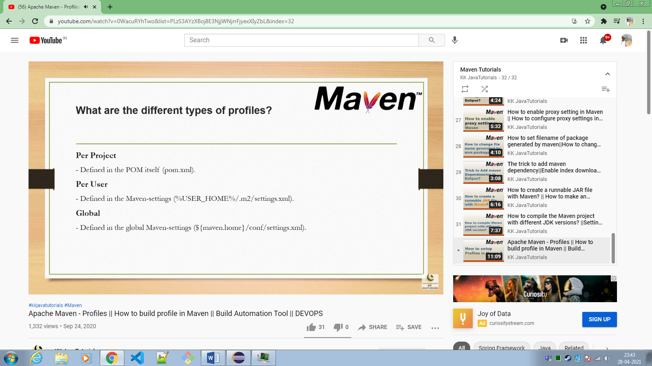S

**HOW TO DEPLOY MAVEN PROJECT MAUALLY:**

1. mvn clean (cleans previous build i.e target folder)
2. mvn compile (compiles the code)
3. mvn test (runs the specified test cases)
4. mvn package (This will create a .jar,.war etc file in the target directory)
5. java -jar Dserver.port=8080 <jar-file-name> (deploy the app in localhost:8080)